Executive Summary
The Maricopa Health Center Governing Council (MHCGC) together with the Maricopa County Special Health Care District Board (District) are co-applicants in the award of the HRSA designation to operate Federally Qualified Health Center Look Alike (FQHC LAL) clinics providing primary and preventive health care and related services (including, but not limited to, ancillary services), regardless of an individual’s or family’s ability to pay. This document was developed to create the vision and strategic priorities for the LALCS00037: MARICOPA COUNTY SPECIAL HEALTH CARE DISTRICT, PHOENIX, AZ.

Mission, Vision and Values

The Mission Statement of the MHCGC is: Serve the population of Maricopa County with excellence, comprehensive health, and wellness in a culturally respectful environment. In their role, the MHCGC entered the process to create the strategic plan. The discussion of overall context for the development of the plan, included current data and trends, and the assessment of the FQHC LAL clinic’s strengths, weaknesses, opportunities, and threats ensuring the strategic plan would be tailored to the needs of the community. The framework for the strategic plan is built upon the organization’s stated mission and the core values it embraces in pursuit of a positive vision for the future.

Mission

Our mission is to provide exceptional care, without exception, every patient, every time.

Vision

Our vision is to be nationally recognized for transforming care to improve community health.

Values

Our values guide how we treat each other, our patients, families and visitors.
- Accountability We hold ourselves and each other accountable by accepting personal responsibility for all that we do and stewardship of the resources we deploy on behalf of our community.
- Compassion We demonstrate sensitivity to our patients and each other by offering emotional, spiritual, cultural and physical support.
- Excellence We are committed to delivering breakthrough quality and service that exceeds expectations, improves outcomes and provides exceptional patient care.
- Safety We ensure a safe environment for all and a highly reliable, effective care experience.

Purpose

The LALCS00037: MARICOPA COUNTY SPECIAL HEALTH CARE DISTRICT, PHOENIX, AZ.
Strategic Plan is a description of the organization’s goals and objectives that expresses its values and
addresses the needs of the population served. Its purpose is to enable the MHCGC and the MIHS FQHC LAL clinics to establish priorities, guide planning, and define strategy that allocates resources and energy to fulfill its mission. The specific focus is on strengthening the capacity of the ambulatory care network improving the health of the populations served, to foster the development of a workforce that can conduct the necessary functions effectively, to communicate the value of local community health, and to maintain and improve the infrastructure to support those needs.

The process for developing the strategic plan included information from the 2017 UDS and the 2018 Community Needs Assessment which contains patient surveys from each of the FQHC LAL clinics to ensure the voice of the customer is heard. In addition, the work over the past 18 months planning the transformation of the FQHC LAL ambulatory care network through Care Reimagined was an additional tool containing critical information regarding the community served. Utilizing this planning elevates the strategy to a new level of delivering healthcare to the community. Of which the central purpose is to redefine and broaden the use of the word “care” into everything we do – we care about our patients, we care about our community and we care about the quality of work we do every day.

From this information, the MHCGC completed a Situation, Weaknesses, Opportunities, and Threat (SWOT) analysis. Conducting a SWOT analysis involves identifying the organization’s internal strengths and weaknesses and the external opportunities and threats or challenges. The SWOT tool is a framework for organizing and looking at the information that informs the big picture view. This analysis helps the organization clearly define the context, which is critical before the organization can identify and prioritize strategic issues.

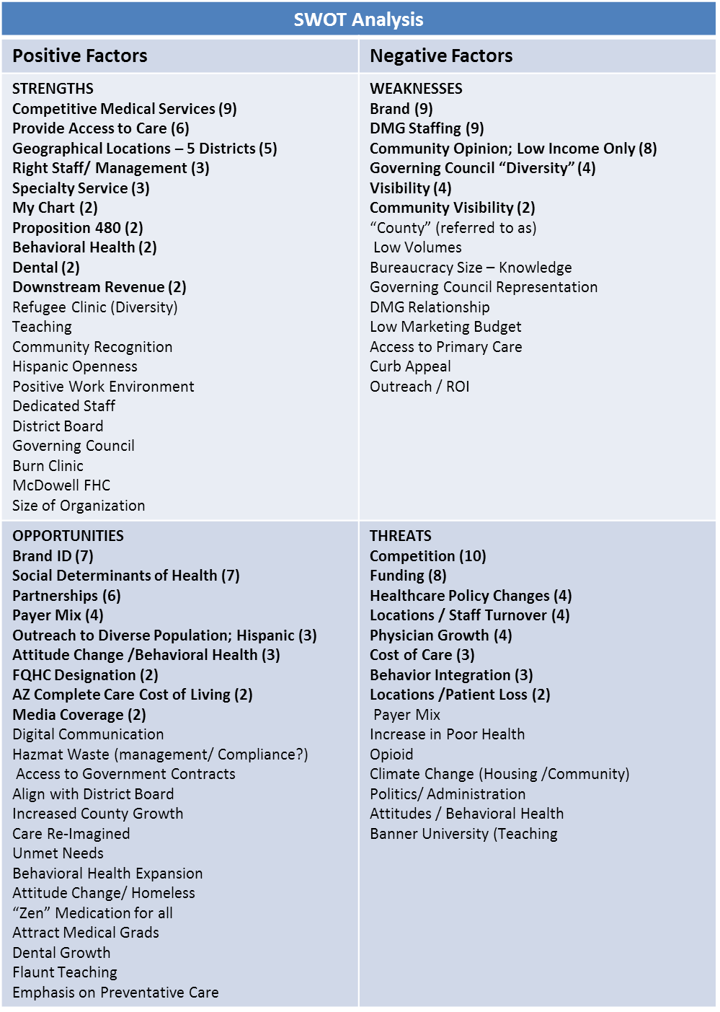

Strategic Goal Areas and Objectives

The next two to three years will be committed to four primary Strategic Goal Areas. Staff led action plans will be developed for each goal area. MHCGC members will support these goal areas by participating in and providing feedback on initiatives and events in collaboration with the Special Health Care District Board, monitoring progress.

Goal Area 1 Growth & Service Line Development: Increase visibility and credibility with the community including patients/families, insurers, and the community. Strengthen engagement with current and potential members, partners, payers, policymakers, and stakeholders.
Objectives
- Through marketing and branding, create community recognition that “Valleywise” FQHC LAL clinics are collectively the largest and best primary care provider for all Maricopa County residents.
- Compile and interpret relevant data to tell a compelling story of MIHS FQHC LAL clinics’ value.
- Identify special population and their needs to determine models of care identifying intervention for improved health i.e. behavioral health, chronic disease management, culture, race or gender issues.
- Use current technology and social media tools to better understand and access special populations, as well as track patient/guest feedback.
- Identify community resources, partners, payers, policymakers and stakeholders developing collaborative efforts to improve the community’s health.
Goal Area 2 Operational Excellence: Improve operational excellence; access to care, clinic throughput and productivity becoming the community health provider of choice.
Objectives
- Monitor the Ambulatory Dashboard evaluating for
  - Negative outcomes: determining cause and interventions to gain improvement
  - Positive outcomes: determine lessons learned and assess for broader application
- Promote continuous performance improvement leading to constant and consistent operation improvement.

Goal Area 3 Stewardship of Resources: Provide oversight and guidance as innovative care and service coordination models are developed to ensure finances and capital expenditures for the provision of quality safe patient care.
Objectives
- Provide direction and oversight in the development of the annual budget.
- Maintain oversight of capital equipment allocations to ensure safe patient care.
- Review and monitor all fiscal reports to ensure appropriate financial management practices are employed.
- Research and regularly communicate the latest developments in payment reform to MHCGC members.
- Explore and determine the value of attaining full FQHC designation/Health Center Program grantee status.
Goal Area 4 Culture of Excellence: Quality, Safety & Patient Experience: Effectively use data to support health center performance and collectively demonstrate the value that FQHC LAL clinics provide.
Objectives
- Research predictive health analytic tools and technology to support and inform potential health center interventions.
- Assess resources and access to UDS actionable data and analytics in the development of population health care.
- Optimize and maintain a centralized data management system with comprehensive and viable data keeping the MHCGC informed to determine action steps for improvement.
- Identify and provide training needed for improving integration of services across the care continuum, managing population health, and providing whole-person care.

Evaluation and Monitoring Progress

The strategic goals and objectives will be evaluated quarterly utilizing a balanced scorecard. The scorecard will be focused on measurable objectives with an achievable timeline. This scorecard will be used by the Strategic Planning and Outreach Committee, the MHCGC, and Management Team to monitor the progress on achieving the strategic priorities. In compliance with the Co-Applicant Operational Arrangement¹, the MHCGC will receive preliminary approval by the District Board. The scorecard will also be used to communicate progress to FQHC LAL Staff and the community.

1 Co-applicant Operational Arrangement between the Maricopa County Special Health Care District and the Maricopa Health Center Governing Council, approve December 6, 2017.

